A2_part1 – Zoe Nelin

Task 1 screenshot of code working
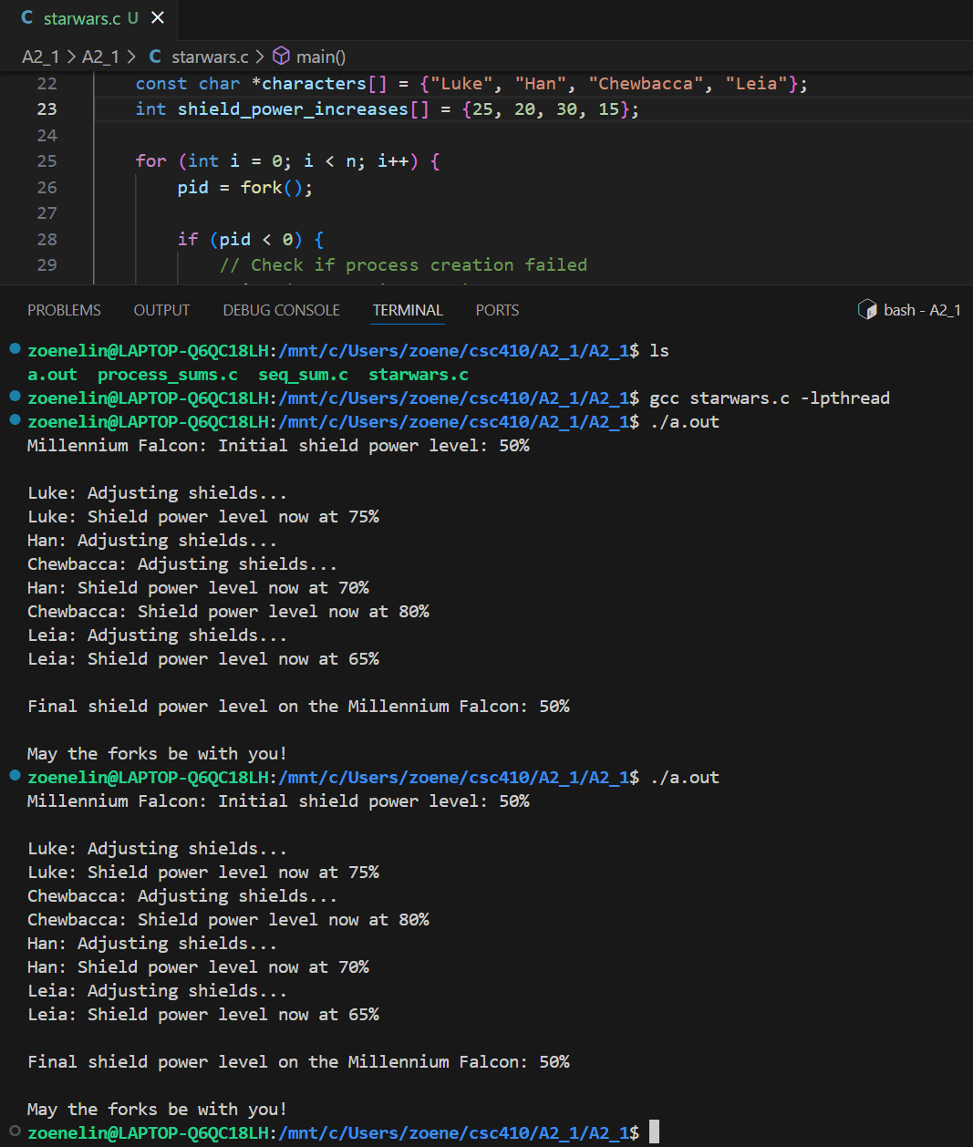
Task 2
- Why does the initial and final value of the shield power remain unchanged?
The reason the initial and final value of the shield power remain unchanged is because each child and the parent got their own copies of the global variable in memory. So when one child makes a change to the global variable that is the shield power, the changes only effect their copy and not that of the other children or parent.

- Why does the order or output change every time you run the program?
Its nondeterministic scheduling.

Task 4
Time both your sequential and parallel sums program for N = 100,000,000 and fill out the table below.
Program | Sequential | 1 process | 2 processes | 3 processes | 4 processes
Time taken | 0.479s | 0.405s | 0.357s | 0.329s | 0.270s

After running the “same” program both sequentially and parallel with a different number of processes, I noticed that the parallelization of the program beats the sequential program every time. Each time you add another process, you gain time or put better, the program takes less time to complete. In my table above and the screenshots below you will see that each time added process decreases the time.

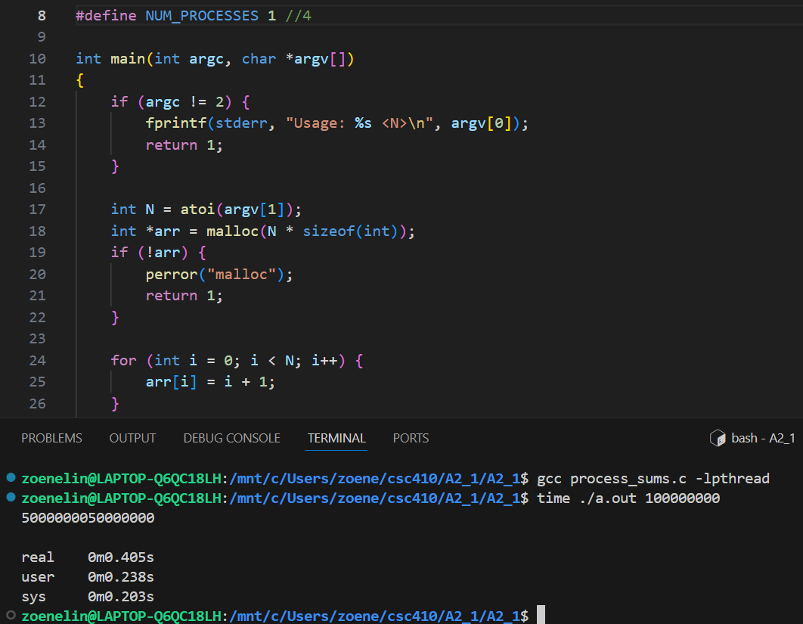
1 process

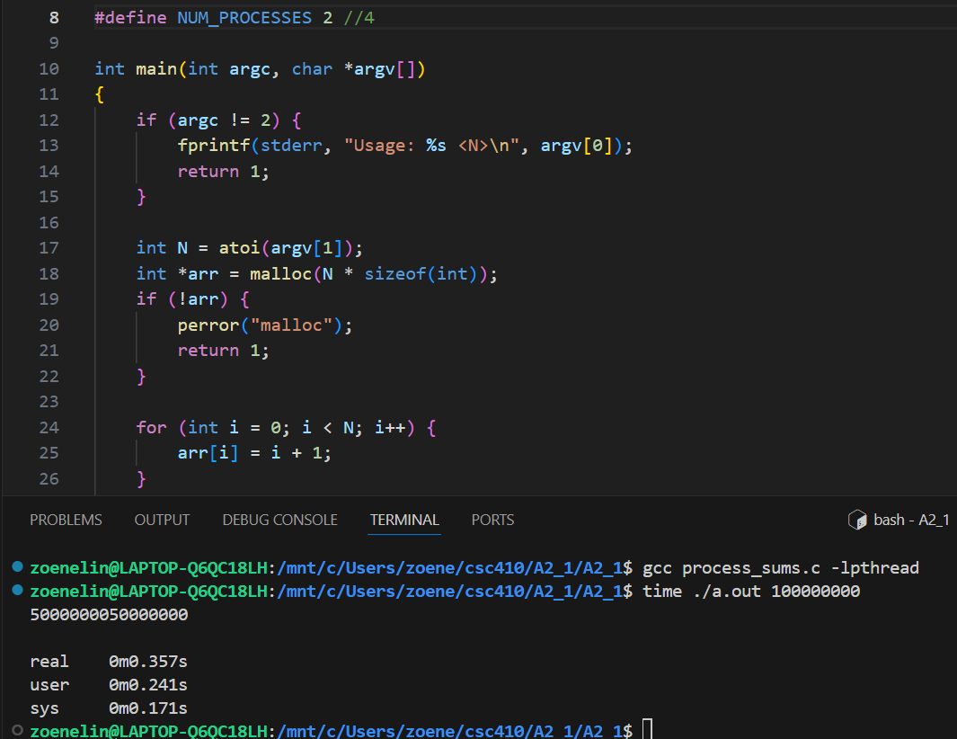
2 processes

3 processes
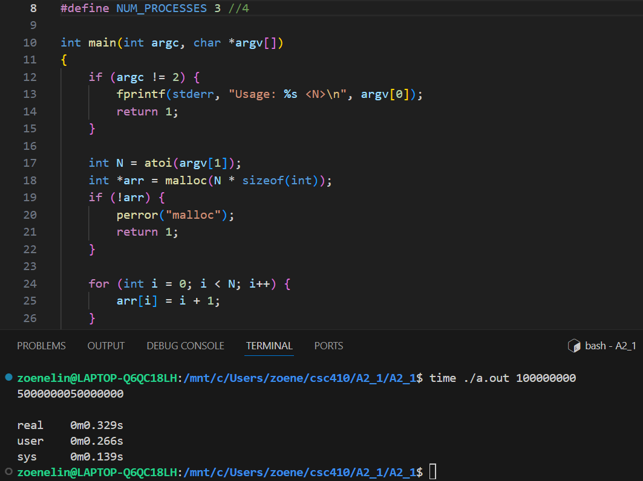

4 processes
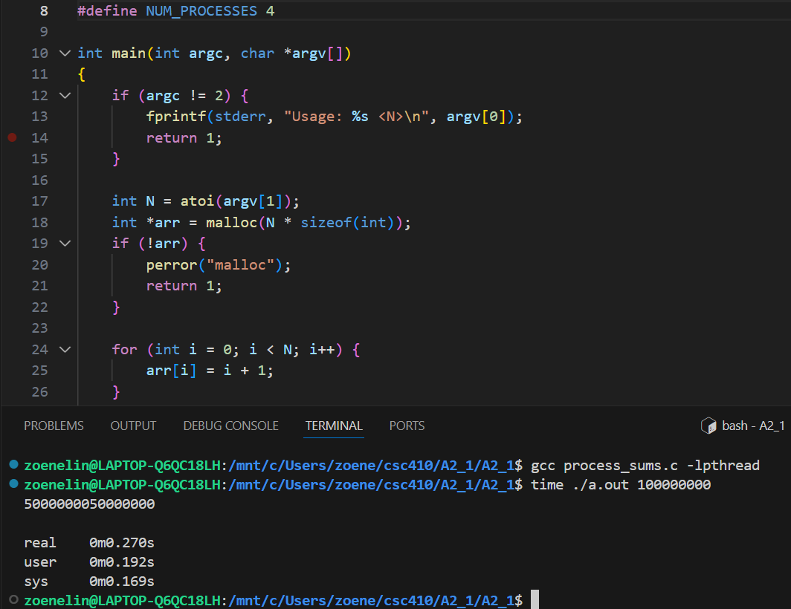

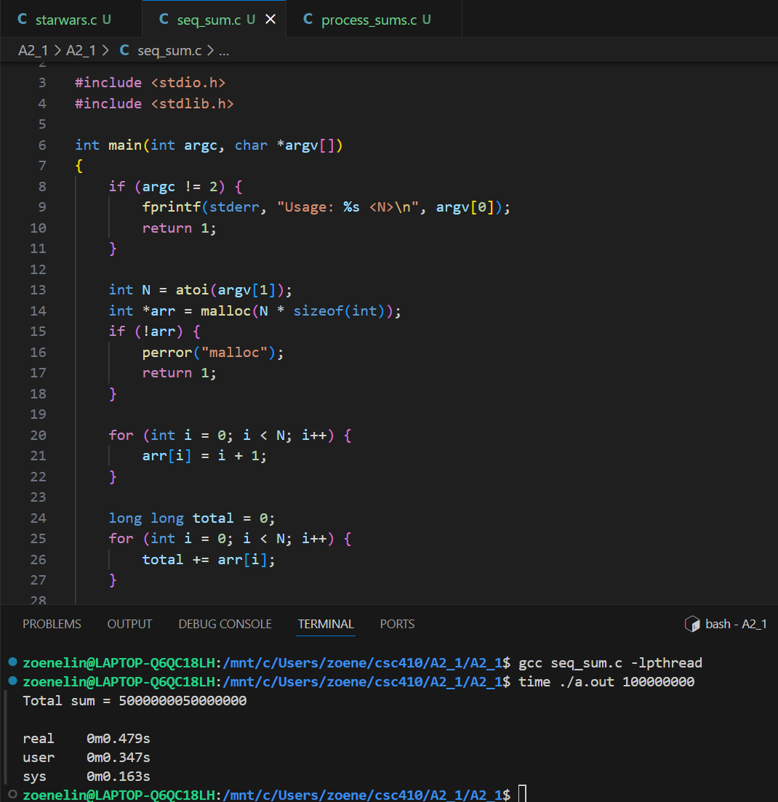
Sequential

